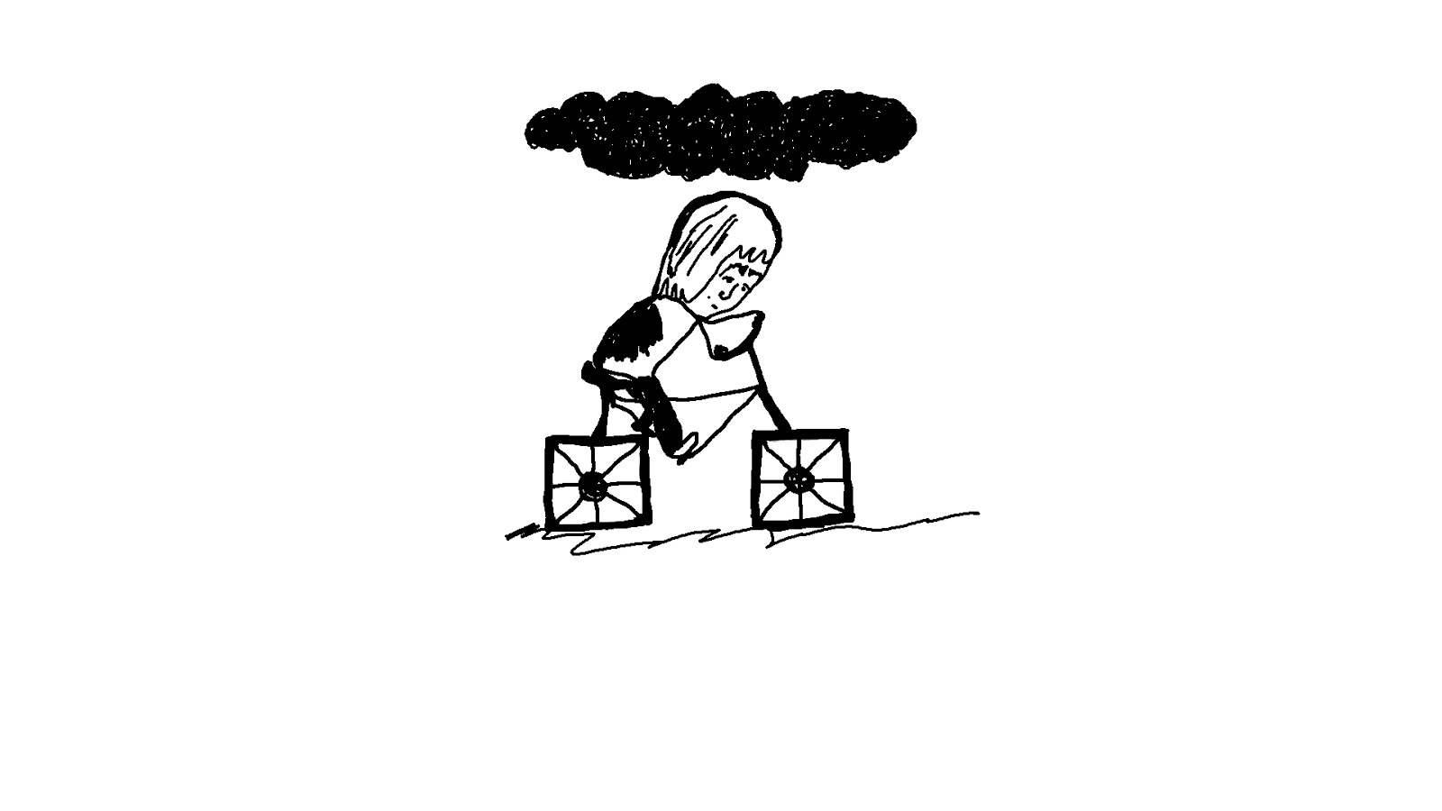

Is Art Therapy Effective in Treating Childhood Trauma?

Faculty: Kingston School of Art
Module Title and Code: HA6101
Dissertation: Research & Reflection
Full Dissertation Title: Is Art Therapy Effective in Treating Childhood Trauma?
Your Name and K number: Oana Laura Giuverdea K1722585
Degree Course: BA (Hons) Illustration and Animation
Word Count: 6455 words
Academic Year of Submission: 2019/2020

Table of Contents

List of Figures | 4
Acknowledgements | 5
Introduction | 6
What is Post Traumatic Stress Disorder (PTSD)? | 9
Childhood Trauma | 11
Transgenerational Trauma | 14
Why Study Trauma? | 16
Healthy Memory versus Traumatic Memory | 17
Representing Childhood Trauma Through Art | 19
Traumatised Artists and Their Art | 22
Art’s Therapeutic Potential for Healing | 27
Conclusion | 35
Bibliography | 37

List of Figures

Figure 1. Bessel Van Der Kolk (2014), “Five-year-old Noam’s drawing made after he witnessed the World Trade Centre attack on 9/11.” in: The Body Keeps the Score, Penguin Books, UK, p 52.
Figure 2. Una (2015), illustration from the graphic novel Becoming Unbecoming, Oxford, p.7
Figure 3. Jessica So (2017) Untitled [Installation], East Sussex College (Viewed: June 2017)
Figure 4. Oana Giuverdea (2018), illustration from the four pages comic strip “My mind is like a crazy uncle”, Kingston School of Art, p.2

Acknowledgements

Many thanks to everyone who has helped with the dissertation especially to Andy McGregor for proofreading and support, Jessica So for guidance towards my healing process and for providing infinite inspiration and materials about PTSD, Ioana Bordea for always being there for me and Ben Weltman for being next to me during the last months.

Introduction

“We are on the verge of becoming a trauma conscious society” (Von Der Kolk, 2014, p.347).

Although Van del Kolk is speaking about the United States, it is nonetheless a worldwide problem mainly because post-traumatic stress disorder (PTSD) is not seen as a condition that affects ordinary citizens. However, it does. As an art student who suffers from complex PTSD, I decided to explore through my work and this written dissertation whether or not art as therapy can help survivors of childhood abuse overcome their struggles with PTSD. Through the use of books, journals, graphic novels, films, Ted Talks, interviews and emails to relevant parties including psychologist Sami Moukaddem, my own therapist and other survivors of childhood trauma, I gained a more comprehensive picture of the issues surrounding PTSD and Art therapy.

A key text from me was “The Body Keeps the Score: Brain, Mind, and Body in the Healing of Trauma” by Bessel Van Der Kolk mainly because he was one of the first to write about and study PTSD from the point of view of ordinary citizens rather than just war veterans. He also makes a valuable point that trauma is not only stored in the brain but in the body itself and is linked to illnesses including heart disease and respiratory problems. This book led me to explore other books, journals and Ted Talks that are linked to PTSD and art therapy.

In this dissertation, PTSD will be explained and shown to be related to anyone who has experienced or exposed to traumatic events. I will be concentrating on childhood trauma and the reasons why trauma should be studied. Later, traumatic memories will be explained followed by an analysis of visual examples of trauma sufferers’ art. Finally, art’s therapeutic potential will be evaluated with more examples including one from my own portfolio.

Because the human mind is such an abstract concept, sometimes it is easier to understand mental health through metaphors and that is why one of the most important roles art has to play is to describe iconic states of the mind, such as depression, grief, terror, melancholy (Solomon, 2013).

Having survived a series of traumatic events, I find myself searching for methods to extract these traumatic memories out of my unconscious and subconscious mind, process them with appropriate feelings towards the original encounter and re-file them in more conscious ‘folders’. There have been times when art has been the only way to express what I have lived through and how I feel regarding my past. While looking for something that reflects my state of mind in the outside world, I have read books on trauma, I have listened to sad music, I have watched films in which characters get through complicated life issues as a consequence of a troubled childhood. I have compulsively done this over the last few years precisely because it gives me the feeling that I am not alone, there are other people sharing similar struggles for example, the alcoholic and homeless Stuart Shorter from the film: “Stuart: A life backwards”. I suffer from complex post-traumatic stress disorder that seems to come out into my art, or in my art preferences. A lot of the time I find myself searching for artists that have been through something horrible in their childhood, and many times I reflect on the fact that maybe that particular traumatic event prompted increasingly intense imaginative encounters.

Through my investigations, I have realized that post-traumatic stress disorder is not solely a mental illness but also a physical illness, a condition of the body and the psyche. It strangles one’s vitality and puts the sufferer in a continuous depression and is not something that a sufferer can ‘snap out of’ – as one is so often told to do by non-sufferers - but is something that individuals can work on, grow around and like many suffering artists, aim to reflect in the outside world. For example, as I will mention in the Chapter Traumatised Artists and their Art, processing individual trauma can also assist others in recognising and processing their own wounds. Trauma is a negative, overpowering encounter that becomes silently solidified in the body, similar to a growing tumour, from the moment it happens. It worsens later in life until the moment you get the chance to process it. And depending on an individual’s circumstances the later a victim of trauma heals the wound the more its effect will have influenced the sufferer’s life. But in modern societies, which often emphasises individuality over community, finding the courage to open up and ask for help can be an ordeal in itself, especially in a world where the simplest interactions lead one to deny the suffering many individuals feel. As Moukaddem exemplifies in his TED Talk “On living with depression and suicidal feelings” if asked by somebody “how are you?” most people usually feel pressured to answer “I am good thanks” (Moukaddem, 2014). But so many people, whether they are aware of it or not, suffer from post-traumatic stress disorder without knowing what it is or if they do, deny that it can be applied to anyone but those who have experienced extremely traumatic events such as war or disasters of some sort.

What is Post Traumatic Stress Disorder (PTSD)?

“Most modem textbooks concur in describing…” PTSD “...as comprising three groups of symptoms: (i) the recurrent and distressing reexperiencing of…” a traumatic event “...in dreams, thoughts, or flashbacks; (ii) emotional numbing and avoidance of stimuli reminiscent of the trauma; (iii) and a permanent state of increased arousal” (Crocq, 2000).

When it was first described, what is now referred to as post-traumatic stress disorder was generally only related to soldiers who had suffered severe shock (shellshock) during conflicts such as the First World War. Their suffering (stress) continued well after the war as if they were still deeply involved in the war, hence the use of the term ‘post’. Unrelated to war, Freud described one of his patients as “suffering from memories” (Freud, 1895) and a few years before that Pierre Janet explained traumatic stress as “…an illness of not being able to be fully alive in the present” (Janet, 1889). Thus, when somebody who suffers from post-traumatic stress disorder, the body and the mind continue to defend themselves against a threat that happened in the past. That is why dissociation, flashbacks or recurring dreams are symptoms of PTSD.

In his book “The Body keeps the Score”, Bessel van Der Kolk talks about how, through his medical practice, he discovered what trauma is, and how it leaves deep traces on someone's life by affecting the mind and emotions as well as their biology and the immune system (van Der Kolk, 2014, p1). He recounts how the psychiatrist Abram Kardibner called it “traumatic neuroses” (Kardibner cited in van Der Kolk, 2014) in the first book van Der Kolk could find about this condition. Both, Kardibner and van Der Kolk shared and understood the same understanding of the fact that PTSD symptoms are not only in the sufferer’s mind but also in the entire body as a response to the original wound (van Der Kolk, 2014, p11). Unfortunately, as they discovered, this distressing disability does not only occur to war veterans but to anybody who has been a victim of a traumatic event. For instance, in many cases children who have been exposed to violence or an abusive upbringing will suffer from PTSD. A further distinction to make is that PTSD is usually associated with a single traumatic event, while complex post trauma is linked to a chain of abusive events, or one long term traumatic experience, for example an on-going physical and/or sexual abuse. Moreover, stress-related psychiatric disorders can even be transmitted from one generation to another and this will be discussed in the chapter Transgenerational Trauma.

Childhood trauma

There are five types of child abuse, as recognised in the UK Government guidance Working Together to Safeguard Children in 2006; physical abuse, sexual abuse, emotional or psychological abuse, neglect and bullying (NSPCC, 2019, p.1). Furthermore, if a child is repeatedly abused by their parents or caregivers, their inner map of the world contains a different message than that of a child who has had good parenting while growing up. Children cannot choose their parents and they are also conditioned to be faithful to their caregivers, so they have no choice but to organise themselves in order to survive the abusive situation in which they find themselves (van Der Kolk, 2014, p133). This intolerable aspect of trauma can be seen in children that have been sexually molested. In order to survive the shame, weakness and this memory of terror that they carry around, they behave like nothing has happened, they try to remove the awareness through the use of denial (Bessel, 2014, p2).

People with a history of abuse in their childhood learn that pleading or crying doesn't bring help and it doesn't make the abuser stop. Brutalized children learn tricks to survive the dark times, which change their perception of the world, and that's why they face challenges later in life, and in order to heal they need to become self-conscious and with professional therapy they can redraw their inner map so that they can gain a sense of trust and confidence in themselves and ultimately the wider world . The price of trying to suppress the memory from their system and not thinking about the traumatic experience is high; they lose track of their feelings and their identity and they don't know who to trust anymore. Later in life, when trauma is triggered, the trauma can be exposed or released in different ways, such as excessive amounts of stress, anxiety, depression, nightmares, panic attacks, flashbacks or strong physical sensations. A trauma trigger is a harmless psychological stimulus, like a smell a feeling, a noise or an image that makes the individual’s body react as if it is in danger because it reminds the sufferer of what happened before or during a key past disturbing experience.

It would definitely seem to be the case that our minds are shaped by our initial encounters in life. Several studies mentioned by De Bellis and Zisk (2014) indicate that a trauma experienced in the early stages of somebody’s life frequently has significant impacts upon the individual’s development as a person. And Van Der Kolk maintains one of the most prominent factors leading to the development of PTSD is childhood maltreatment (2014, p148). Furthermore, the American paediatrician, Nadine Burke Harris revealed in 2014, in a Ted Talk, that child maltreatment can affect brain development, have an impact on the immune system, hormonal systems and even the way our DNA is read and transcribed. Also children who suffer from bullying or cyberbullying, emotional abuse, neglect, physical abuse, sexual abuse and other types of violence or accidents, have triple the lifetime risk of lung cancer and heart illnesses and a 20 year difference in the average period that a person may expect to live (Nadine Burke Harris, 2014).

Research published in the Proceedings of the National Academy of Sciences (Mehta, Klengel, Conneely et al., 2013) indicates that abused children get a unique form of PTSD, which has significant biological effects. As the paper states,” Childhood maltreatment is likely to influence fundamental biological processes and engraves long-lasting epigenetic marks, leading to adverse health outcomes in adulthood.” (Mehta, Klengel, Conneely et al., 2013). In other words, the research suggests that maltreatment of children does not only leave scars on their brain and body but most significantly, may leave its mark on their genes as well. This differentiates childhood trauma from other forms of PTSD such as stress related psychiatric disorders in adult survivors of war trauma. All in all, one can be left in adulthood with the feeling of being damaged to the core and the fear of never being able to get better. However, one needs to be more childlike in approaching one’s trauma and not see it through adult eyes but rather approach it through the eyes of innocence. As the poet Wystan Hugh Auden wrote:

“Yet truth, like love and sleep, resents
Approaches that are too intense,
And often when the searcher stood
Before the Oracle, it would
Ignore his grown-up earnestness
But not the child of his distress.”
(Auden, 1941)

If one sees the ‘oracle’ as the person’s own truth, we can see that it does not address the adult with their complexities and intense analysis. Rather it addresses the child as the original sufferer.

Transgenerational Trauma

It is now common in psychological theory to also recognise the aspect of social or intergenerationally transmitted trauma. There are studies (Fossion, Rejas, Servais et al., 2018 and Williams, Malcoun, Sawyer et al., 2014) with evidence which show that if a community survives an atrocity such as the Holocaust or slavery, the second generation and beyond are susceptible to the traumatic effects of their parents' horrific pain and that each generation itself is already a transporter of unprocessed wounds. In fact, through such mechanisms of human transmissibility, suffering can become mentally transitive, influencing society as a whole through prolonged exposure and longitudinal propagation. In other words, trauma impacts not only those who are subject to it personally, but also those surrounding them. For example, the partners and children of the soldiers returning home suffering from post-traumatic stress disorder. In the process of acculturation, children adopt many things from their parents.

Nevertheless, the unconscious memory of compromised parents can also be conveyed to the point that the perceptual present of a child is preoccupied with the history that he or she never encountered personally, and from which overwhelmed consequences it can become the locus as well as tactile and imaginative relationships . This transmissibility involves secondary damage, which can also become more than affliction; it provides a means to turn the painful remains on the other side of the defeat (Pollock, 2013, p9 ).Furthermore, gender related transgenerational trauma is also particularly highlighted by feminists and is of relevance to my example of Una in the chapter ‘Traumatised Artists and their Art’. Women are particularly vulnerable and more often the victims of the patriarchal societies that perpetuate themselves through the societal normalisation of sexist relations between the sexes that is passed down through the generations. Vogel (1994) also states that females in the family are more susceptible to trauma “The female children, with their greater emotional openness and the capacity for identification with parental feelings and experiences, may unconsciously become the carrier of traumatic experiences that parents disown or suppress.”

Why Study Trauma?

Trauma has been studied and analysed in the context of medical science, psychoanalysis, shamanism, art and social justice, amongst others because it has such a devastating impact on those who suffer from it, their families and or future generations. Therefore, trauma can be recognised as one of the most urgent and important public health challenges facing the world.

Griselda Pollock recognises that the premise in trauma research is the need for people and communities to address the ' wounding ' in different ways that, according to our trauma hypotheses, gives rise to symptomologies like the desire to replicate childhood situations and experiences in adulthood and act them out. Childhood trauma possesses and inhabits our adulthood (Pollock, 2013, p1) and prevents us from living in the present moment. Being plagued and occupied by trauma leaves no room for the present life. Trauma is stuck as a foreign intruder in the psyche, colonizing the hosts through its relentless persecution - and because it is a long term condition that has no definite cure and can be transmitted intergenerationally - in order to stop a perpetual traumatic pattern of abuse, those who suffer from PTSD need to have appropriate help and support from both the medical profession and the society they live in. It is important to become a trauma-conscious society, in order to understand the complexity of PTSD.

Healthy Memory Versus Traumatic Memory

It is important to define what a healthy memory is before attempting to describe the memory of one who suffers from trauma. Healthy memories do not intrude upon the present in the way that a traumatic memory does. Unhealthy memories occur when something terrifying happens and the faculty of the brain is in shock causing the system of memory to break down.” As a result, the imprints of traumatic experiences are organized not as coherent logical narratives but in fragmented sensory and emotional traces; images, sounds, and physical sensations.” (Bessel, 2014, p176). This means that if somebody was a victim of a traumatic event, that person might not remember the full situation as it happened, maybe only small parts of it, and the memory can be altered in terms of time. On the other hand, if the distress is too painful for the individual, the memory of it is very often pushed out of consciousness to the unconscious and the victim loses the memory of it, and can become unaware of the fact that something tragic happened to them. On the positive side this is how our brain protects us in order to survive such inescapable shock. Getting the memory out of conscious perception is a psychological coping ability. That is why a trauma occurrence might not be kept “as a narrative with an orderly beginning, middle and end.” (Van Der Kolk, 2014, p.135) Traumatic memory has two difficult characteristics to endure: a heavy quietness and a terrifying timelessness.

However, because it has not been processed it is projected into the sufferer’s everyday life and impairs their ability to sufficiently deal with the present realities. The impossibility of remembering such traumatic events is called repressed memory but it is possible to recall those recollections when triggered or with professional support in psychotherapy.

To sum up when somebody experiences constant recollections and is suffering from tragic memories and being flooded by disturbing sensations and dark images, or alternatively does not have the memories but experiences nightmares or exhibits behaviour that cannot explain why they react in a certain way such as experiencing severe anxiety, then is very likely connected to past traumas.

Representing Childhood Trauma Through Art

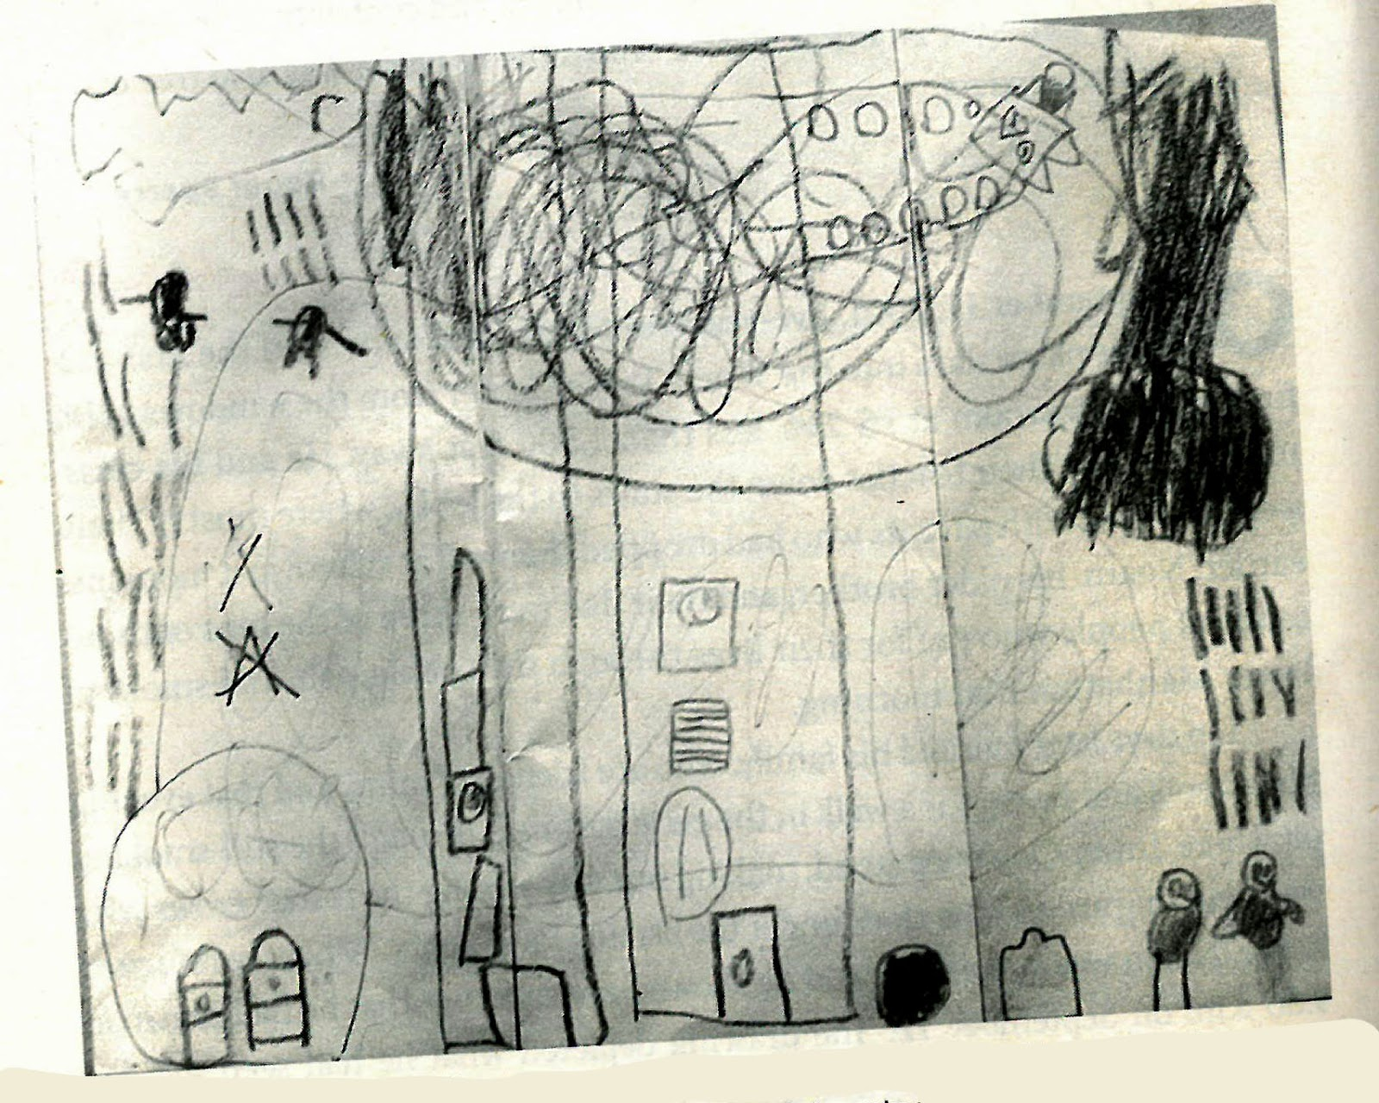
Figure 1. Bessel Van Der Kolk (2014), “Five-year-old Noam’s drawing made after he witnessed the World Trade Centre attack on 9/11.” in: The Body Keeps the Score, Penguin Books, UK, p 52.

Eighteen years have passed since the tragic events of 9/11 and they still remain etched into the memories of ordinary Americans. Such a traumatic event broadcast live on TVs everywhere has had a lasting traumatic influence to varying degrees depending on how geographically and emotionally proximate one was to the events of that day and the images of its aftermath. The events are “...still relevant as a symbol of U.S. political and military vulnerability…” that undermined the popular belief of US impregnability with such shocking abruptness, and as Horton states, as a locus for debate about the importance of trauma as a concept in Western culture (Horton, 2019, p1). Those traumatised by the events of that day would have typically had to shift from dissociation to association, in order to successfully understand their experiences if they responded emotionally according to the gravity of the incident.

One of the studies presented in “The Body Keeps the Score” is about a child called Noam Saul, who was only five years old when he witnessed the catastrophic event of 9/11. He saw from the window of his classroom the first airplane hit the World Trade Centre. The next day after the attack, Noam drew a picture (fig.1) about what he had seen, experienced and understood on September 11, 2001 (Van der Kolk, 2014, p51). Noam reproduced from his memory the passenger plane hitting the tower of offices, creating an explosion and a big fire around it. He also drew the people inside the building, firefighters on the ground next to the tower and people jumping from the windows. Van Der Kolk asked Noam questions about some of the details of his drawing and he revealed that the black circle at the bottom of the building is an actual trampoline ; “So that the next time when people have to jump they will be safe” , Noam explained (Van der Kolk, 2014, p52).

Noam accessed his memory and imagination and used a pencil on paper to make different types of marks and dynamics, some clear and thick, some thinner and scribbled that give the uncomfortable sensation that whatever he experienced was not easy to represent. But although hard to create, this drawing has a massive importance for Noam’s psychological wellbeing: it helped him recall the traumatic event and process the disaster he had witnessed and carry on with his life having all the support he needed from his family.

I have chosen Noam’s experience as a positive example of how art, in this case memory drawing, if used in the early stages after a traumatic experience, can allow the brain to make sense of what happened and by using the imagination the child created a life-saving alternative to what he had seen. In this way he integrated the infernal event he saw in his life without suppressing it, or becoming stuck, but with the engagement of both body and brain; the act of drawing and the understanding of safety. However, it can be argued that Noam’s trampoline may hide the fact that Noam dissociated the real horrific scenes of bodies hitting the ground and surrounding structures. Therefore, this imaginative artistic intrusion to the reality his mind refused to see might still need to be processed in the future as it might result in unexplained anxieties, nightmares and other symptoms of stress related psychiatric stress disorders later in life. And furthermore, in adulthood his rational mind might actually question the effectiveness of the lifesaving apparatus and thus trigger the real memories of that day.

Traumatised Artists and their Art

Griselda Pollock asserts that trauma is all abiding, lies below the surface of consciousness and is not tied to an accessible imagination. Griselda goes on to claim that an artist’s life’s journey may unknowingly lead to that which is abstract and not -yet - experienced, i.e. trauma itself (Pollock, pxxvii). Although many artists do this unconsciously some artists do go to therapy and consciously explore their inner world through their highly personalized work. In contrast to Noam (fig1), who was fortunate to have the support of his family and seemingly managed to free his mind from the disaster, other traumatized children become stuck and in these cases, trauma can continue to affect their entire organism, body, mind, and brain during their lifetime towards adulthood and beyond before confronting their inner demons. One such artist is the graphic novelist who prefers to be anonymously known as ‘Una’.
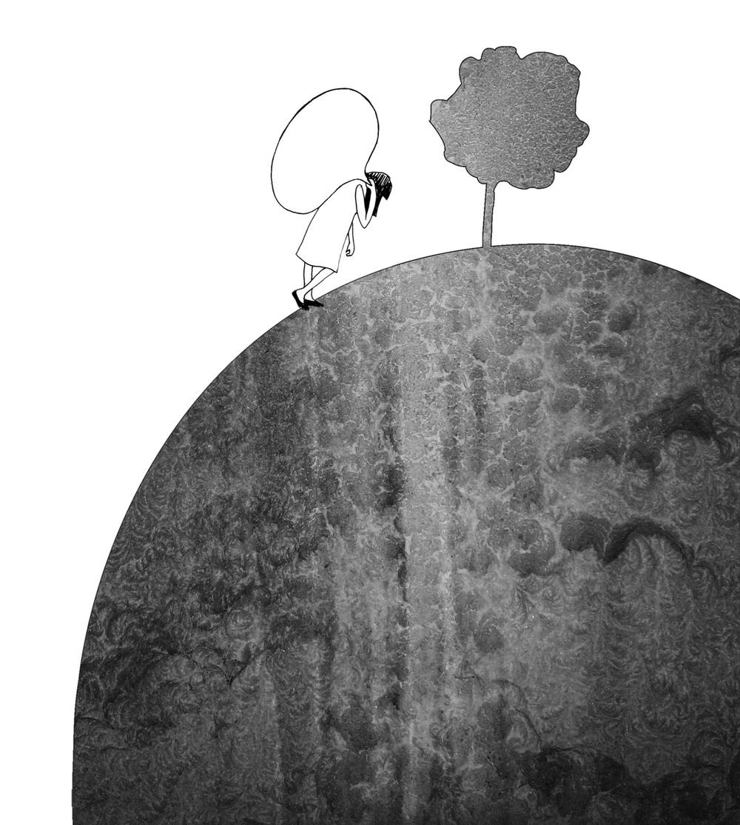
Figure 2. Una (2015), illustration from the graphic novel Becoming Unbecoming, Oxford, p.7

Courtney Donovan and Ebru Ustundag emphasise the importance of graphic narratives that explore traumatic experiences because they can provide a wider understanding of trauma beyond the long-established legal and therapeutic structures that can only provide limited understanding of trauma and hamper justice mechanisms for those who have experienced it (Courtney, 2017, p221).

As presented in the “Comic Reviews”, “Becoming Unbecoming” is a daunting debut graphic novel filled with statistics, figures and publicity around the topics that explores sexual violence and public response to it in United Kingdom. The artist, aged 50 at the time she published the graphic novel, juxtaposes her own formative years with the Yorkshire Ripper hunt, which aimed to capture Peter Sutcliffe in the late 1970s because he had murdered 13 local women and attempted to murder seven more. She also reveals in her vivid autobiography personal stories of multiple sexual assaults and articulates her own psychological history in the broader social sense of gender violence, digging deep in her thoughts, using words and vivid collage of drawing styles that seem to be spilled out of her personal journal. In this way she is highlighting the connection between her own traumatic experiences and those of other sexual assault victims (2015, vol 262).

As stated in the “Graphic narratives, trauma and social justice” article, ‘Becoming Unbecoming’ is a vital focus on making available the uncertainty and discomfort of violence and the impact of sexual assault encounters on the sense of self and personal development of a survivor from an early age (Donovan and Ustundag, 2017,p 229).

In the very first image in the book, Una shows an eerie image of her younger self carrying a heavy, hollow speech bubble, which is a common leitmotif in her work which gradually begins to contain words as she speaks out about her trauma or burdens. She draws the figure scaling a steep hill and emphasises the almost impossible unbearable task of being a silent victim of abuse through the efforts of carrying such a heavy silent burden (Figure 1). As Donovan and Ustundag say, the lightness of the seemingly flat empty speech bubble is made to appear full when represented as a heavy sack to carry. The lack of terms in the bubble foreshadows the cumulative effects of unspoken suffering, the resulting of a victim-blaming society, and the unrealized prospects of redress (2017, p 229). The emptiness of the speech balloon shows sensitivity to invisibility of past abuse and conveys trauma-related personal and social silences but it can also be seen as a metaphor for the unbearable heaviness of remembering as her traumatic memory starts to unfold from the beginning of the book. This is a strong representation of the quietness aspect of trauma. The lack of colour from her illustration , the huge weight of the empty bubble on her shoulders, that can also be seen as a sack filled up with invisible silenced traumatic experiences, her slow difficult walk up the muddy dirty hill which represents the survivor’s life of childhood of abuse. All these elements together are a clear metaphor for the ongoing process of post traumatic trauma; the timelessness characteristic of the complex PTSD.

On the one hand, although we don't know Noam’s mental health evolution, if he was affected later in his adulthood by this one traumatic event he had witnessed when he was a child, then he would suffer from post-traumatic stress disorder. On the other hand, Una survives an ongoing trauma, and a series of abuse that she talks about in the book and also how it affected her life. What Una experiences is complex post-traumatic stress disorder.

Nevertheless, young Una is marching alone towards a tree on what seems to be a small planet, perhaps emphasizing the distance the woman needs to travel with her burdens. Meanwhile, one could interpret the tree as the ancient emblem of the tree of life, which can signify physical and spiritual growth, transformation and redemption in the action of rising up to heaven, calling for more knowledge and wisdom to recover from the past. The writer later discusses the number of young girls impacted by these fragmented experiences and the feeling of loneliness: "too many girls have to fight in silence" (Una, 2015, p. 169). When Una begins to understand and speak about the unnamed and unspeakable violence of her trauma, she depicts the speech bubbles as containing words but also as a balloon. She floats above the landscape holding the balloon that keeps her buoyant and gives her a clearer view of the world, which had been so invisible around her (Una, 2015, p113).

Art’s Therapeutic Potential for Healing

As presented in the preface of the book “After-affects|After-images: Trauma and aesthetic transformation in the virtual feminist museum”, artists can be traumatized by the remnants of politically derived historical events whether through personal experience or mediated in some way. This begs the question, is it possible for artists to transform these remnants of trauma through artistic practices? And what methods can we deploy in order to understand whether or not it can be achieved? (Pollock, 2013, p.xxi). Several studies do show some success in art therapy (Pifalo, 2007) but not all sufferers respond well to this approach. Pifalo claims that art assists children in making choices through their artwork and therefore encourages a sense of control over their trauma. Noam’s drawing of a trampoline to help the victims of 911 survive is a case in point. It was also a device he chose by himself to overcome the horrific images he witnessed that day and therefore gave him some control over a situation he was in reality unable to affect in any way.

However, one could argue that many sufferers do not have an interest in and therefore do not attempt to resolve trauma through art. Studies have revealed that for those that do, not only do different types of psychotherapy help survivors recognising and understanding post trauma but also different types of art can help sufferers acknowledge the invisible forces they are battling with. Therefore, it would seem a natural form of therapy for artists to confront their trauma through their daily practice.

In 1953, Cunningham Dax reveals in his book, “Experimental studies in Psychiatric Art” five ways in which artmaking can be used within the psychiatric environment; “as a form of recreation or occupational therapy, in which the patient is able to produce a concrete product; as a cathartic experience that both provides the patient with ‘emotional release’ and doubles as a tool for diagnosis and treatment; as a catalyst for patient progress; as a means of patient expression within the psychotherapeutic context, allowing for interpretation of symbolic imagery; and as a form of research to better understand mental illness” (Dax, cited in Cohen, 2017, p102). Ideally, Dax said counselling art sessions should be conducted in art studios, not clinics, and a partnership should be formed between a teaching artist, to create a conducive creative atmosphere, and a psychiatrist who analyses the patient's artwork. This creates an atmosphere of authenticity and freedom which is usually rarely available to or difficult to achieve for patients who are treated in the context of a therapists’ office.

Unfortunately, given a shared history in a field of mental health, art therapy in a contemporary sense is not specifically linked to a treatment of a mental health problem (Cohen, 2017, p25). Although we have seen in Noam’s example (fig2) that through drawing in early stages of the trauma, he could process the traumatic event he witnessed and by being in the right loving environment of his family he could continue his life without being affected in the long term. Noam chose naturally a form of image making to process the traumatic memory of the 9/11 event. More than that, Una drew and wrote an entire beautiful graphic novel on a very serious subject that firstly helped herself to process what she experienced and also gave a voice to those who cannot speak about them freely .As stated by her at the end of the book ,when Una started to draw, she did not plan to demonstrate the work to anybody. A significant number of her latest drawings will always stay private, yet a portion of the early, very dynamic drawings are incorporated in the novel. They can be comprehended as working on an increasingly unconscious, representative level that words maybe cannot achieve. She trusts this is a decent book, however maybe not a commendable one. Nor was it helpful, yet it has been liberating for her, and it felt like a contribution, as one among many (Una, 2015, p.203). For various reasons, some pieces of work necessitate privacy while others certainly helped other victims of similar abuse and inspire them to conduct their own explorations in overcoming stress-related psychiatric disorders.

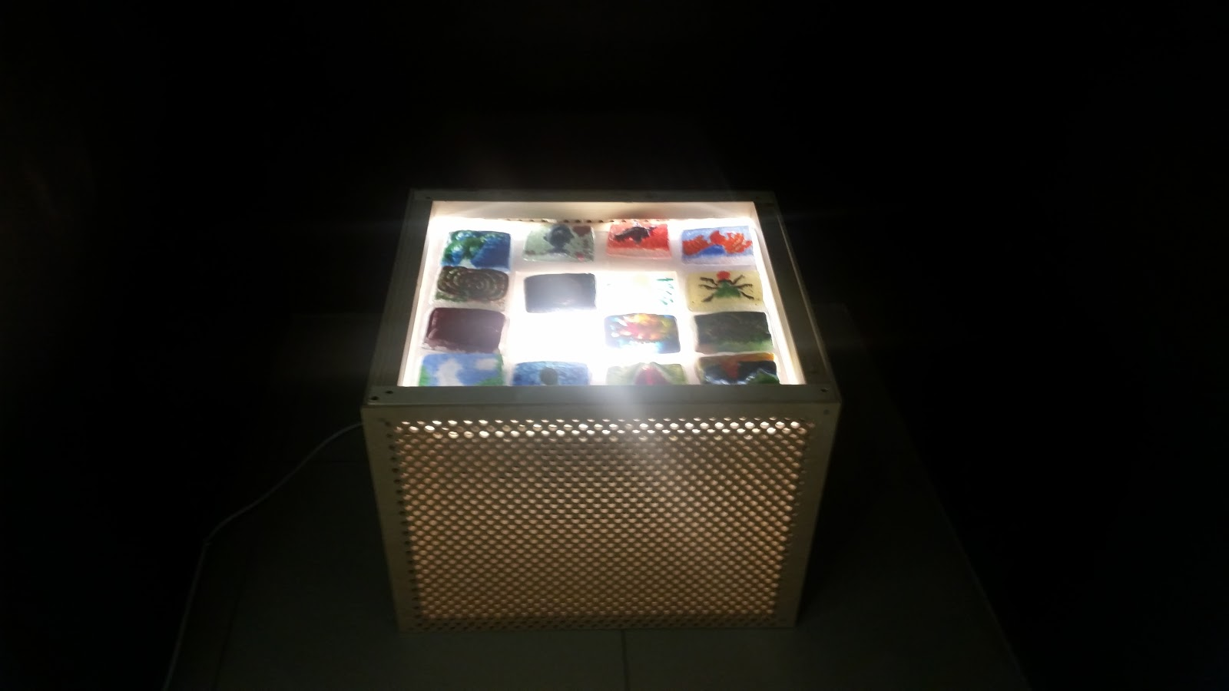
Figure 3. Jessica So (2017) Untitled [Installation], East Sussex College (Viewed: June 2017)

During my foundation course at Hastings College in the UK, I witnessed one of my peers work her way through processing trauma by using images from the cartoon and film characters and crafting them into glass figures which were symbols of her family members that abused her as a child. The glass figurines were set out as a children’s game on a light box (Fig.3) so that their colourful images shone through but the stories behind them were traumatic memories of her time spent with her family members. She explained to me that the unbearable truth represented by the light forced the onlooker to close their eyes until the dark glass images covered the light and their image was revealed bringing unconscious memories into the light so that they could be faced and processed. She wanted to make these figurines as symbols so when she thinks of one particular memory that includes one of her family members, she would not have to ruminate and go through the process of remembering with flashbacks and dissociation and re-experiencing everything over and over again. She wanted to put all that experience and the associated stories in those particular glass figures and when she gets triggered to remember only the anchoring symbol, she chose for it and move on with her life. She confirmed, after a while, that the process was successful for her; the symbols worked but the trauma of course is not just one particular thing that you can resolve, like a cold virus, and you move on from it. It is something that sufferers work on through all their lives as it affects everything, from body to the mind. This might be similar to Noam’s trampoline in that the sufferer is given a way out of ruminating on horrific details and keeps the individual from reexperiencing the trauma while still acknowledging its existence.

One form of therapy that helped me along my journey in understanding and coping with complex post-traumatic stress disorder was exposure therapy. Exposure therapy includes in vivo and imaginal exposure and processing respectively (Tull, 2019).

Exposure therapy is an acknowledged treatment for PTSD and specifically imaginal exposure therapy is where the patient, in this case, myself, has to focus on a particular traumatic event that comes up in a therapy session and focus on it and describe it with as many details as possible. So, I had to confront a memory that made me still feel frightened in the present, yet realistically I was in a safe environment. It felt like I was being stimulated and triggered and safely conducted through flashbacks by the therapist, until I was able to process and analyse the traumatic experience and reduce the impact it had on me. Being a survivor of an ongoing abuse during my life in my birth country, my inner map on how I perceive and react to the world was severely damaged. Therefore, I have trouble distinguishing between danger and safety. This type of therapy also helped me to have a present inhabited understanding and feeling towards my troubling and traumatic past life.

Instinctual, in my art practice, I have found myself using this method of exposure. Exposing a particular scene from a flashback, a type of anxious thinking , an inexplicable bad behaviour, a nightmare or recurring dream, in a visual context, like illustration or animation, caused me to not only better understand where it was coming from and what it realistically meant to me but also process it and later re-file it in more conscious folders in my mind. Experimenting with self-directed art therapy, made me visualise more easily the problems I am dealing with and in some successful cases reduced the troubled symptoms of the complex post-traumatic stress disorder.
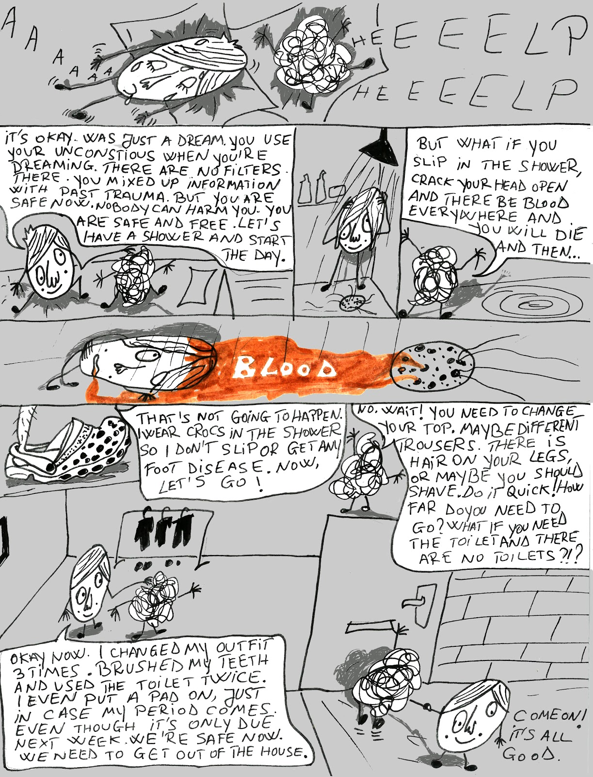

Figure 4. Oana Giuverdea (2018), illustration from the four pages comic strip

“My mind is like a crazy uncle”, Kingston School of Art, p.2
For example, in my second year at university I completed a four-page comic strip that focussed on my severe anxiety involving irrational fears caused by past traumas and family abuse (fig. 4). Comedy and the comic book medium allowed me to confront my traumas humorously and in a more child-like manner appropriate to when these anxieties began to take hold. The brain-like character represents anxiety and the other more realistically drawn character represents the part of myself that wishes to heal and converse with the anxious self and parent it in a more rational understanding and loving way. It helped me to process my irrational anxieties and open a dialogue with my anxious child self that enabled me to overcome these fears and deal with them on a daily basis. I still wear Crocs but for more rational reasons concerning catching skin diseases in showers which are shared with fellow housemates.

Conclusion

In this dissertation, PTDS has been defined as a condition that affects more people than is often realised. Childhood trauma is particularly prevalent and different to other forms of adult post-traumatic stress disorder and is therefore important to understand in more depth. As discussed, art therapy can be effective in the treatment of PTSD as shown in the visual examples of Noam, Una, my college peer and myself.

This dissertation has taught me a number of things in relation to my practice as an artist suffering of complex PTSD. First of all, it has helped me to recognise through my own work the traumas I was only partially conscious of, while also helping me to externalise traumas in order for me to have an open dialogue with them and process my wounds in an honest and refreshingly childlike manner. It has been in many cases more effective than a dialogue a professional psychologist. Secondly, my research has shown me that trauma is linked and causes psychosomatic illnesses such as heart or respiratory diseases which made me more aware of my own trauma through the recognition of bodily symptoms. This is speeded up my recovery and my awareness of how “The body keeps the score” of any unconscious past traumatic events. Furthermore, Una’s book, “Becoming Unbecoming”, revealed how sharing one’s traumas can help other survivors of abuse recognise and engage with their own troubling past.

I am grateful that having moved to the UK from Romania it is clear to me that mental health conditions such as PTSD is far more recognised in this country and allows sufferers to deal with their issues more openly and with support from professionals with experience in the field. It is my wish that art therapy will be taken more seriously by psychotherapist as a way of dealing with these issues. I hope that more artists and therapist will collaborate on equal footing in helping subjects of stress-related psychiatric disorders and that not only my own country but that other nations across the world will begin to take this issue more seriously and take more preventative measures towards child abuse including parental and child education programmes.

Ironically, I have spent all my youth trying to run away and forget my past, but in the last few years I have learned that in order to heal myself I have to recall, confront and process traumatic memories through art and therapy. Only by doing this can I truly live in the present and not be a prisoner of my past.

Bibliography

Agorastos, A., Aversa, L., Pittman, J., Goldsmith, C., Nievergelt, C., Hansen, D., & Baker, A. (2013). The cumulative effect of multiple childhood trauma on adult depression, PTSD and health-related quality of life. European Neuropsychopharmacology, 23, S532-S533.
Available at https://www-sciencedirect-com.ezproxy.kingston.ac.uk/science/article/pii/S0924977X13708459?via%3Dihub (Accessed: 11/01/2020)

AUDEN, W.H.(1941). New Year Letter, London, Faber and Faber, First English edition, 8vo, 188 pp.

Burke Harris N.(2014), How Childhood Trauma affects Health Across a Lifetime, September 2014, Available at https://www.ted.com/talks/nadine_burke_harris_how_childhood_trauma_affects_health_across_a_lifetime?language=en#t-2372
(Accessed:07/01/2020)

Cohen R. (2017). Outsider Art and Art Therapy, Shared histories Current Issues and Future identities, UK: Jessica Kingsley Publishers

Crocq MA, Crocq L.(2000) “From shell shock and war neurosis to posttraumatic stress disorder: A History of Psychotraumatology.” Dialogues Clin Neurosci.0;2(1):47–55.

Donovan C., Ustundag E. "Graphic Narratives, Trauma and Social Justice." Studies in Social Justice 11.2 (2017): 221-37. Available at https://journals.library.brocku.ca/index.php/SSJ/article/view/1598
(Accessed: 15/12/2019)

Horton, E. (2019). “21st Century Trauma and the Uncanny: A Gothic Reading of Trauma in Pat Barker’s Double Vision.” C21 Literature: Journal of 21st-century Writings, 7(1): 7, pp. 1–22. DOI: https://doi.org/10.16995/c21.675

Mehta D., Klengel T., Conneely K., Smith A., Altmann A., Pace T., Rex-Haffner M., Loeschner A., Gonik M. , Mercer K. , Bradley B., Müller-Myhsok B., Ressler K., Binder B.,(2013) “Distinct PTSD biology after childhood maltreatment”, Proceedings of the National Academy of Sciences, May 2013, 110 (20) 8302-8307; DOI: 10.1073/pnas.1217750110

Michael D. De Bellis, MD, MPH and Abigail Zisk A.B.(2014).The Biological Effects of Childhood Trauma , April 2014, Available at https://www.ncbi.nlm.nih.gov/pmc/articles/PMC3968319/pdf/nihms-555973.pdf (Accessed:09/01/2020)

Miriam L. Vogel MSW (1994). “Gender as a Factor in the Transgenerational Transmission of Trauma”, Women & Therapy, 15:2, 35-47, DOI: 10.1300/J015v15n02_04

Moukaddem S.(2014), On living with depression and suicidal feelings, Oct 22, 2014, Available at https://www.youtube.com/watch?v=sorMd2ZHWM8 (Accessed:09/01/2020)

NSPCC (2019). Child protection fact sheet, London: NSPCC. Available at https://www.ncl.ac.uk/studentambassadors/assets/documents/NSPCCDefinitionsandsignsofchildabuse.pdf (Accessed:22/12/2019)

Pierre Fossion , M.D., Mari-Carmen Rejas , L.M.F.T., Laurent Servais , M.D., Isy Pelc , M.D., Ph.D., Siegi Hirsch , L.C.S.W., L.M.F.T.(2018). “Family Approach with Grandchildren of Holocaust Survivors.” The American Journal of Psychotherapy. https://doi.org/10.1176/appi.psychotherapy.2003.57.4.519

Pifalo, Terry (January 2007). “Jogging the Cogs: Trauma-Focused Art Therapy and Cognitive Behavioural Therapy with Sexually Abused Children.” Art Therapy. 24 (4): 170–175. doi:10.1080/07421656.2007.10129471. ISSN 0742-1656.

Pollock G. (2013). After-affects|After-images: Trauma and aesthetic transformation in the virtual feminist museum, Manchester: Manchester University Press

Solomon, A.(2013) Depression, the secret we share, October 2013, Available at https://www.ted.com/talks/andrew_solomon_depression_the_secret_we_share?language=en (Accessed:10/01/2019)

Tull, M., (2019) How Exposure Therapy Can Treat PTSD, Available at: https://www.verywellmind.com/exposure-therapy-for-ptsd-2797654
(Accessed: 3/01/2020)

Van der Kolk B. (2014). The Body Keeps the Score. Mind, Brain and Body in the Transformation of Trauma, UK: Penguin Random House

Walsh M. (2013). Art and psychoanalysis, London: I.B. Tauris

Williams MT, Malcoun E, Sawyer BA, Davis DM, Bahojb Nouri L, Bruce SL (June 2014). "Cultural adaptations of prolonged exposure therapy for treatment and prevention of posttraumatic stress disorder in African Americans". Behavioural Sciences. 4 (2): 102–24. doi:10.3390/bs4020102. PMC 4219246. PMID 25379272.

